|  |  |  |  |  |  |  |  |  |  |
| --- | --- | --- | --- | --- | --- | --- | --- | --- | --- |
| **Test case**  **I*D*** | **Test**  **scenario** | **Test**  **Case** | **Pre-**  **condition** | **Test**  **Steps** | **Test**  **Data** | **Expected**  **Result** | **Post**  **Condition** | **Actual**  **Result** | **Status**  **(Pass/**  **Fail)** |
| TC  Login-001 | To Verify the login module of the website | Login Form of Hospital | Login to system | 1.Enter a username | Valid  User-name | Successful  Login | Home page is shown | Homepage of the Website is visible | Pass |
| 2.Enter  password | Valid  pass-word |
| 3.Click “Login” button |  |
| TC  Login-002 | To Verify the login module of the website | Login form of doctor | Login to system | 1.Enter a  username | Invalid  User-name | Unsuccessful login |  | Homepage of the Website is not visible | Fail |
| 2.Enter password | Valid password |
| 3.Click “Login” button |  |
| TC  Login-003 | To Verify the login module of the website | Login form of doctor | Login to system | 1.Enter a  username | Invalid  User-name | Unsuccessful login |  | Homepage of the Website is not visible | Fail |
| 2.Enter password | Invalid password |
| 3.Click “Login” button |  |
| TC  Login-004 | To Verify the login module of the website | Login form of doctor | Login to system | 1.Enter a  username | Valid  User-name | Unsuccessful login |  | Homepage of the Website is not visible | Fail |
| 2.Enter password | Invalid password |
| 3.Click “Login” button |  |

Login Page test cases: -

Payment Portal Test Cases: -

|  |  |  |  |  |  |  |  |
| --- | --- | --- | --- | --- | --- | --- | --- |
| TC  Payment-005 | To Verify the payment portal | Are all the payment options being displayed | View all the options for payment | ALL the possible payment portal are shown | Details of the payment method is asked | Payment method is also saved | Pass |
|
| TC  Payment-006 | To Verify the payment portal | Can payment be initiated by the given option | Click on one of the payment portal. For e.g. Paytm | ALL the possible payment portal are shown | Details of the payment method is asked |  | Pass |
|
| TC  Payment-007 | To Verify the payment portal | Is the Transaction taking place | Click on one of the payment portal. Enter the necessary details | The details get filled and the payment is intiated | We are asked to enter the OTP | The transaction takes place | Pass |
|
| TC  Payment-008 | To Verify the payment portal | Is the transaction completion email being sent? |  |  | The email is received | The transaction is completed | Pass |
|

Login Page: -

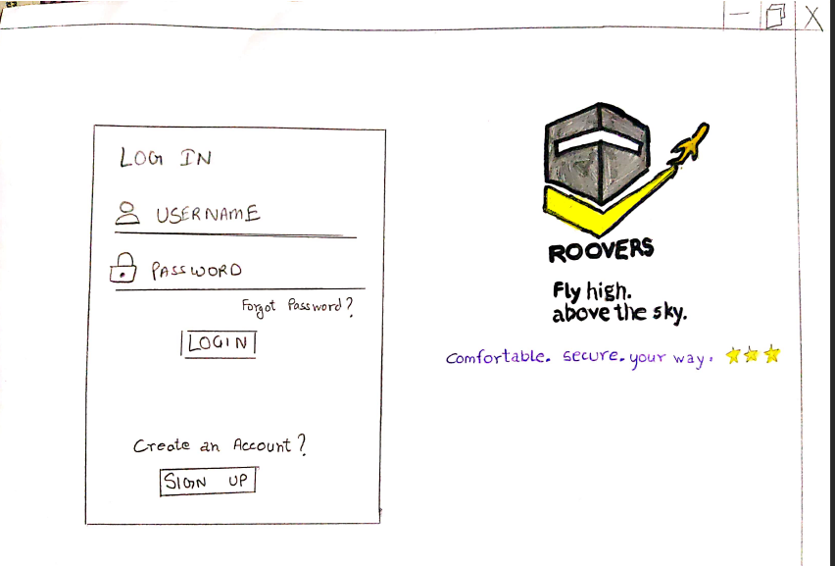

Payment Portal: -

